**University of Petroleum and Energy Studies**

School of Computer Science

Department of Cybernetics



**Graphics & Animation Tools**

**LAB FILE**

**(Session: 2020-2021)**

Course: B. Tech with Specialization in Open Source and Open Standards

Batch: 2017-2021

Semester: VIIth

**Submitted By: -**

Nikhil Mishra

Roll No: R100217043

SAP ID: 500062584

**Submitted To: -**

Dr. Durgansh Sharma Assistant Professor

Department of Cybernetics

**Experiments - 1** Installation of GIMP AND BLENDER

Step: 1. Installation of GIMP 2.10.20 from the official website of the GNU Image Manipulation Program (GIMP) <https://www.gimp.org/>

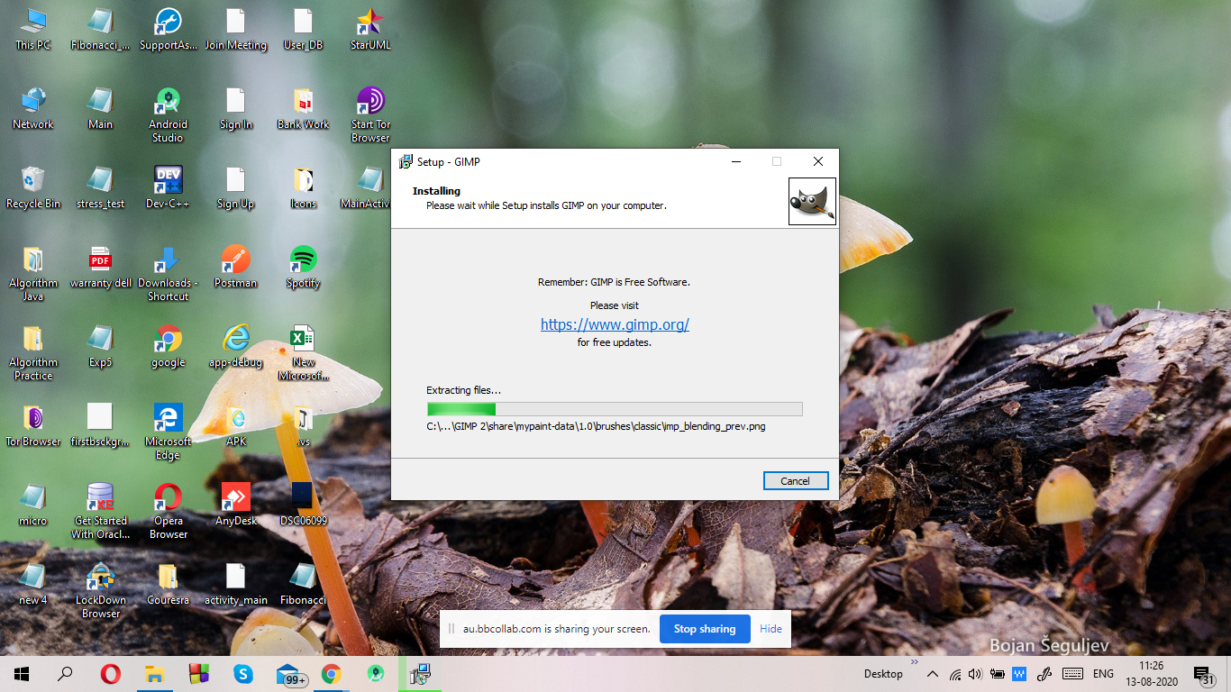

Step: 2. Completing the GIMP Setup Wizard

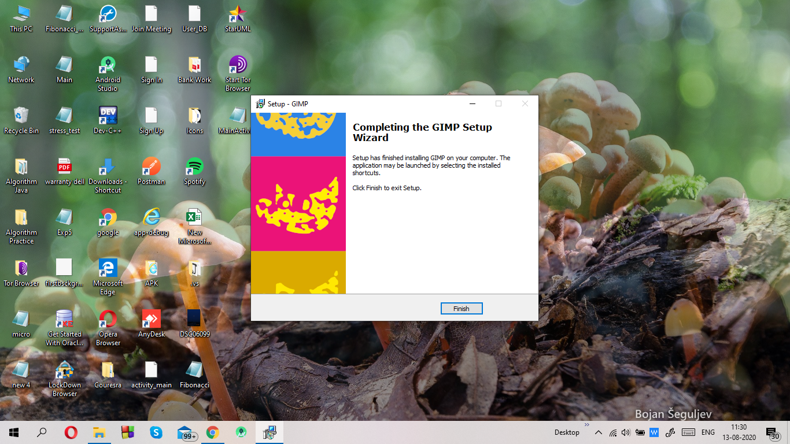

Step: 3. Final step in installation of GIMP 2.10

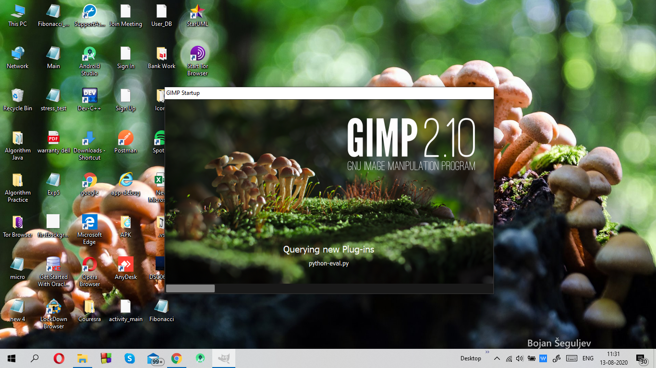

Step: 4. The user application interface of GIMP

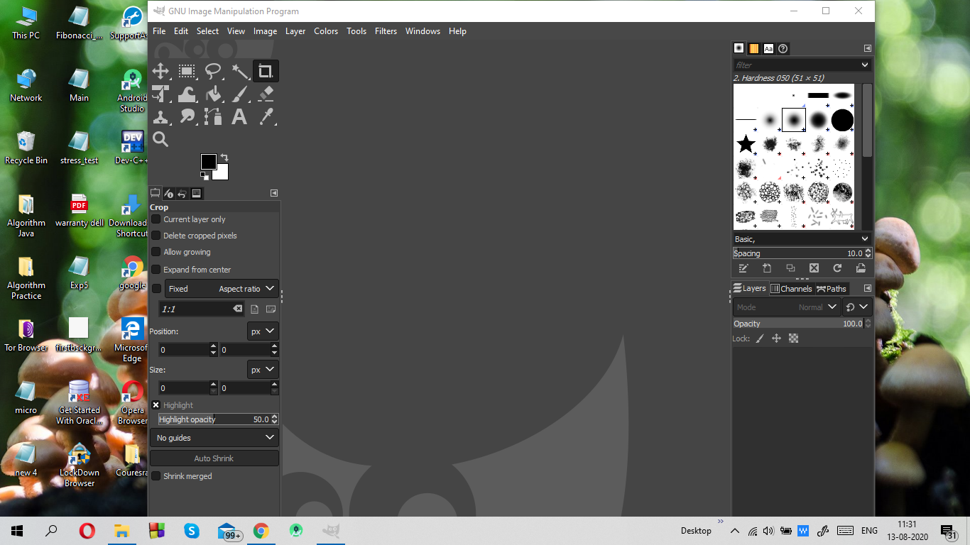

Installation of Blender

Step: 1. Installation of blender windows installer package from the website <https://www.blender.org/download/>

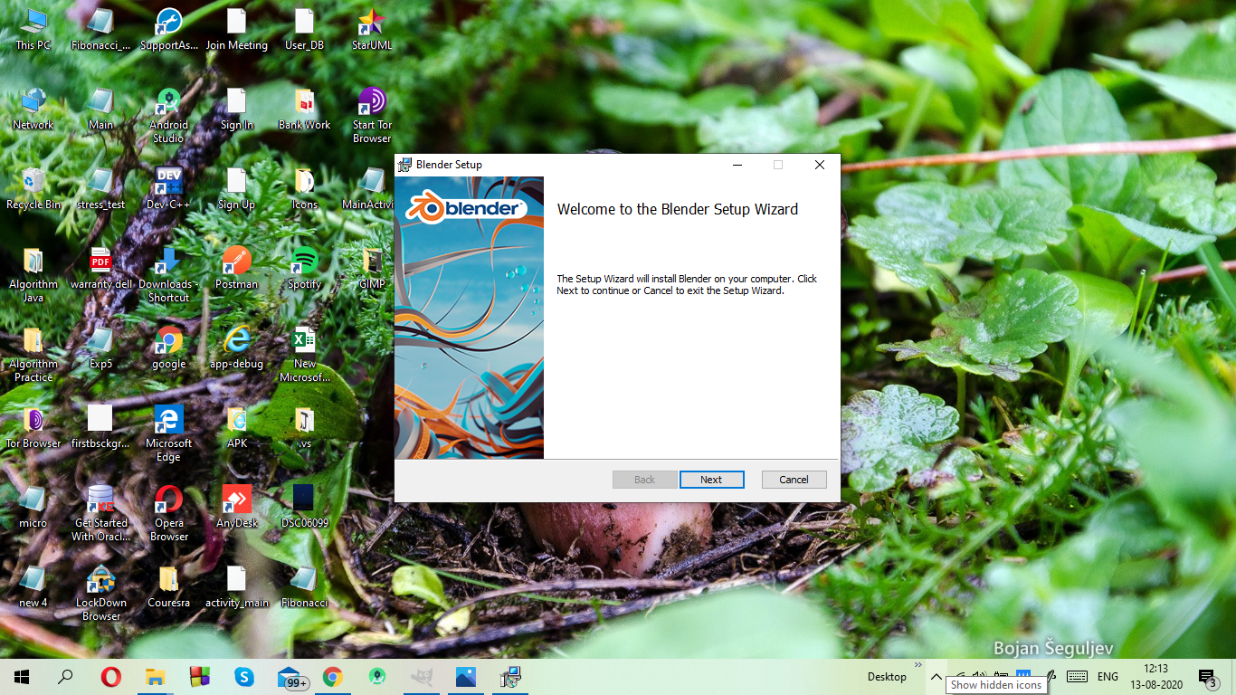

Step: 2. End-user agreement (Accept)

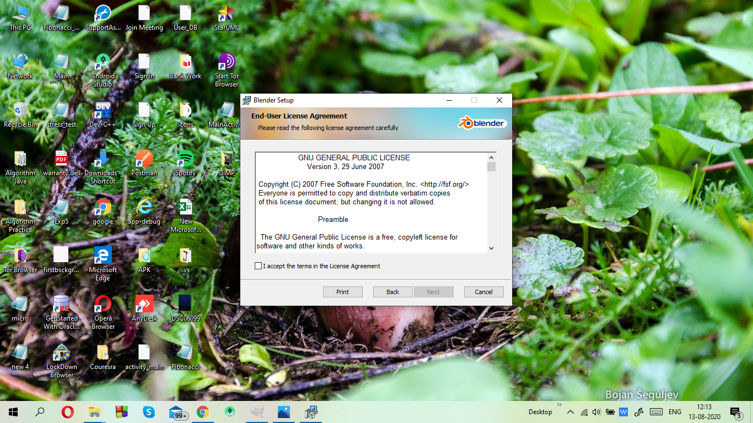

Step: 3. Installing Blender

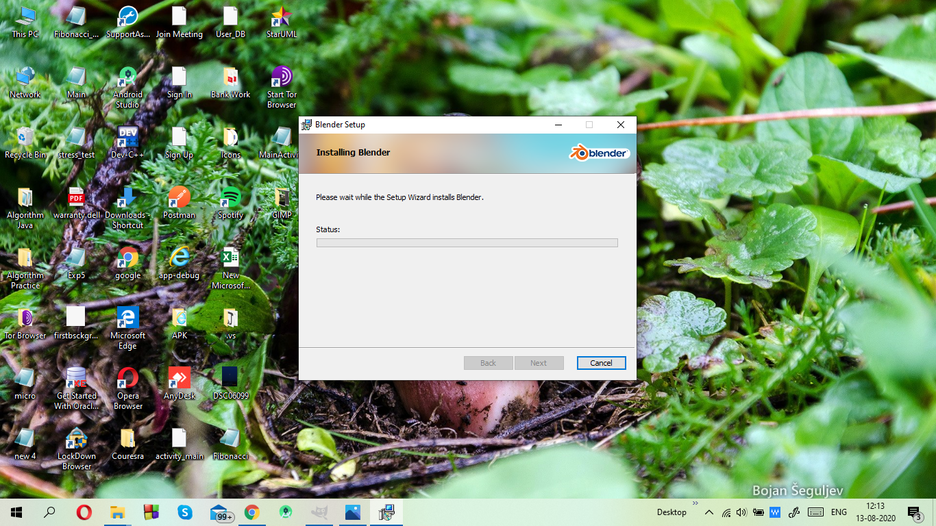

Step: 4. Custom Setup (The memory location where you want to setup your blender). Leave as default in case you don’t want to change anything.

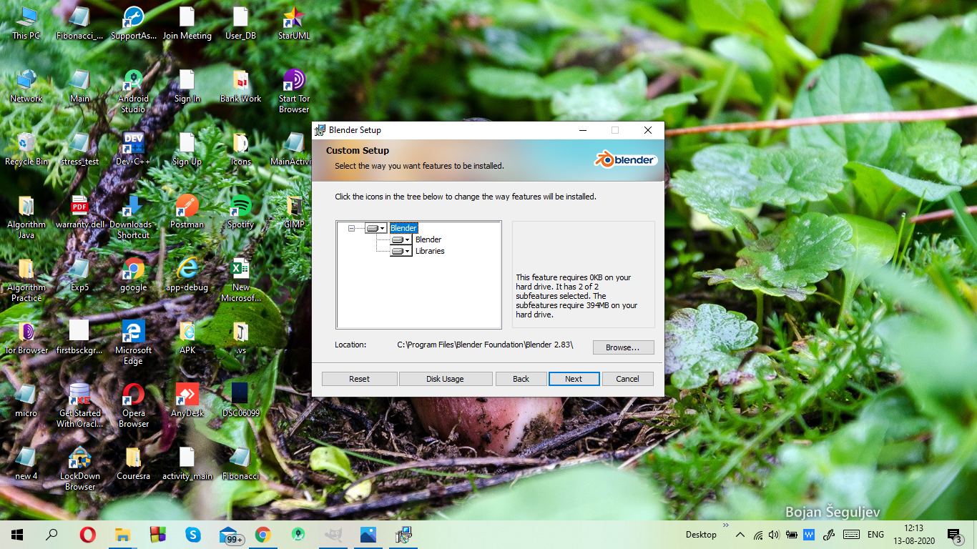

Step: 5. Completion of blender setup wizard. Click on finish to finish the installation of blender.

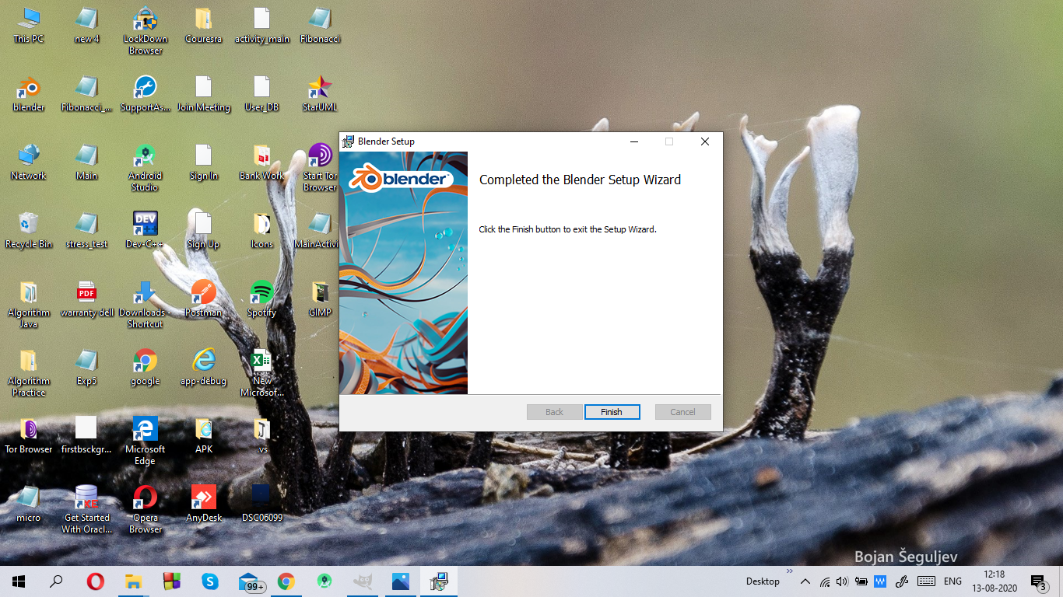

Step: 6. The user application interface of Blender

